BA 4318 BUSINESS DATA PROCESSING WITH PHYTON

Term Project Report

The term project of this course is consisted from three parts. The first part is that predicting the 2014 BIST30 Index values (monthly), through training the data of producer price index, gold price, US dollar currency rates, export data of Turkey and monthly market rate of interest of Turkey. The training data consists from years of 2010, 2011, 2012 and 2013. All of the independent variables and the dependent variable data gathered at monthly frequency, mainly from Yahoo Finance, Central Bank of Turkey and Turkish Statistical Institute.

The second part is clustering the BIST30 stocks. BIST30 includes many powerful and reputable companies from many different sectors in Turkey. Clustering the BIST30 stocks may help us to analyze the relationship between sectors of companies. The clustering could facilitate a stock-purchaser’s fundamental analysis process by the behavior of companies and the sectors.

The last part is creating a multiple-regression analysis as stating BIST30 Index as dependent variable and the other five variables as independent variable. The first step would be looking for the p-values if they are significant for this model or not. We can conclude for an independent variable’s contributions is sufficient in the model, or it does not contribute at all. Beside p-value, we would have the insight which tells that whether these five variables can explain (through R2) the dependent variable. Lastly, we could reach the coefficient value of the variables which indicate the relationship with the dependent variable and a single independent variable.

So, as a whole we may have a general picture of how the BIST30 is affected by these selected five factors, how the BIST30 companies behave among themselves, and a trained data for the prediction may lighten the way if the variables are truly chosen.

Conclusions

Firstly, our multiple-regression output indicates that p-value of all variables except the export variable are significant and smaller than 0.025. So we can say except the export data, the other four variables contribute to explaining the dependent variable. The coefficient values of monthly market interest rate, USD/TRY currency rate, producer price index and gold price are significant independent variables and their coefficients are respectively and rounded as -3.82, -97.098, 1.6343, -0.0223. We can say that an increase at monthly market interest rate, US/TRY currency rate and gold prices negatively affect the BIST30 Index though an increase at producer price index positively affect the BIST30 Index. The coefficient value of USD/TRY is very high, which may be explained through the debt structure of the BIST30 companies can be mainly formed through basing the debt agreements on foreign currency rate. The R2 is very high, though the major contribution comes from the USD/TRY currency rate increase/decrease. With a higher number of observations, R2 result can be much more reliable.

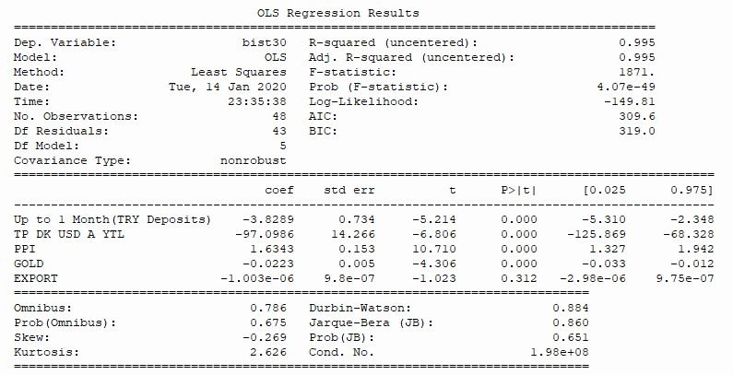

Beside the multiple regression, we also made a prediction about the BIST30 Index for the year of 2014. Outputs can be found below.

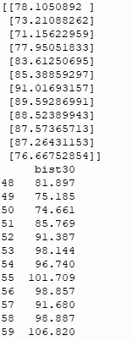

The first one is the prediction and the second one is the real past sata of the BIST30 Index. We can see that the prediction correctly estimated the trends, though the break points were not estimated with a high percentage of correctness. The political events may be a reason for this as well, since the BIST is not still very efficient comparing to developed countries stock exchange markets and can be affected by the speculations and the political events.

Lastly, when we look at the silhouette score, we should use three separate clusters. BIST30 includes several industries that can be affected not only our variables but also several country financial factors. However, BIST30 already includes the most current industries that leads Turkey's economic outlook and weight of production. With the cluster method, we can say that the BIST30 companies can be divided into three groups which moves in different way.